PROJECT PLANNING PHASE
Project Planning Template (Product Backlog,Sprint Planning,Stories,Stories points)
Date | 01-11-2025
Team ID | NM2025TMID07589
Project Name | Educational Organization Using ServiceNow
Maximum Marks | 4 Marks

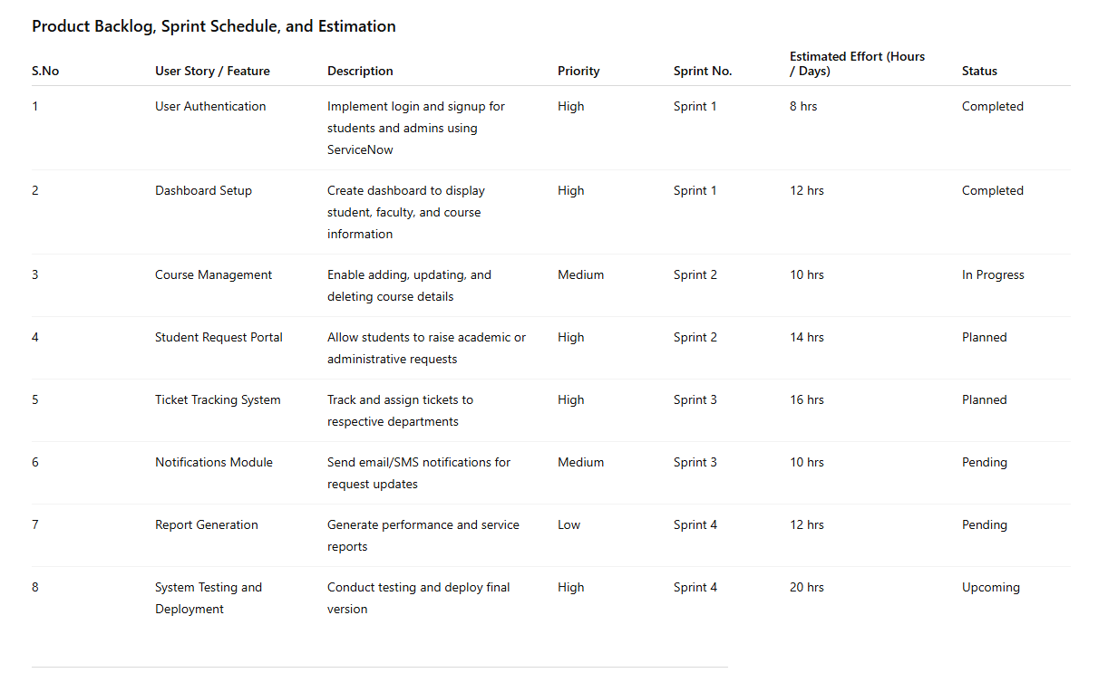
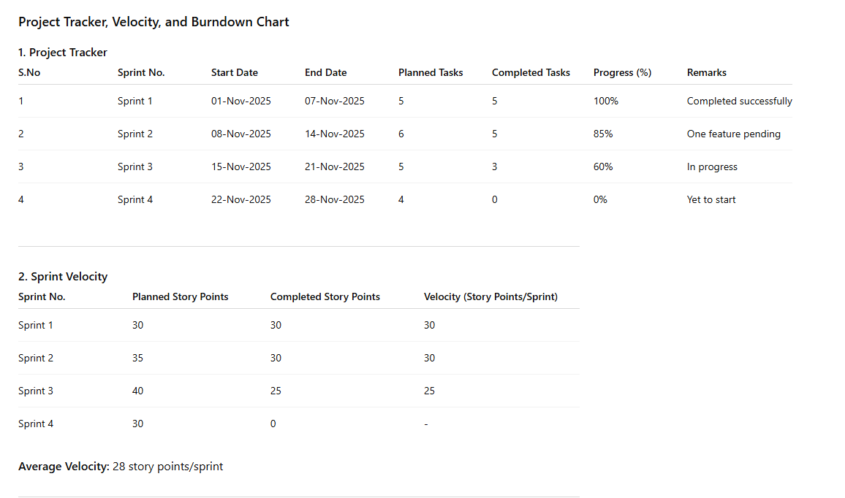
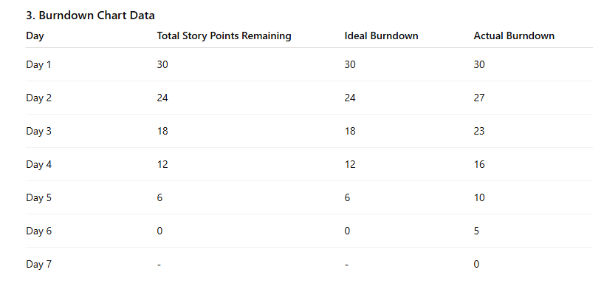
Reference:
Solved: How to find the URL to ServiceNow University (Now ...
Blog #8 - Project Case Study: ServiceNow Implement...
Automating Work Notes in ServiceNow with Hyperlink...
ServiceNow for EDU use cases / challenges / general

